CS 20 Laboratory 6: Common Combinational Circuits

1. (4pts) In the experiment done on Section 2.1, provide a screenshot of the circuit for each possible input combination. Do not forget to label the inputs in the screenshots (0.25pts each).

DBCA = 0000 DBCA = 0001

DBCA = 0010 DBCA = 0011

DBCA = 0100 DBCA = 0101

DBCA = 0110 DBCA = 0111

DBCA = 1000 DBCA = 1001

DBCA = 1010 DBCA = 1011

DBCA = 1100 DBCA = 1101

DBCA = 1110 DBCA = 1111

1. Half Adder
   1. (2pts) Provide the boolean expression to represent the logic of the half adder.

S = (A+B)’

C = AB

* 1. (1pt) Provide the truth table for the half adder.

|  |  |  |  |
| --- | --- | --- | --- |
| Input | | Output | |
| A | B | S | C |
| 0 | 0 | 0 | 0 |
| 0 | 1 | 1 | 0 |
| 1 | 0 | 1 | 0 |
| 1 | 1 | 0 | 1 |

* 1. (0.25pts each) Provide screenshots of the circuit for all possible input combinations. Do not forget to label the inputs in the screenshots.

A = 0 B = 0 A = 0 B = 1

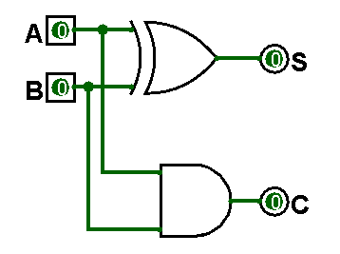 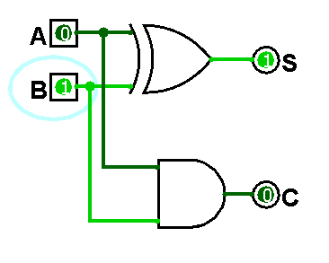

A = 1 B = 0 A = 1 B = 1

